**CNT3004: Computer Network Concepts (Fall 2020)**

**Homework 1 (Chapters 1 - 3)**

**Name: Abdulaziz Alkaabi PID: 4433547**

**A. Answer each question briefly, but completely. When computing an answer, make sure to show how you arrived at your answer. For the hands-on portions, follow the directions but make sure to take a screen shot of your results and paste into your submitted document.**

1. How many layers are defined in OSI model? List them from top to bottom.

**Seven layers are defined in the OSI model.**

1. **Application layer**
2. **Presentation layer**
3. **Session layer**
4. **Transport layer**
5. **Network layer**
6. **Data link layer**
7. **Physical layer**

1. How many layers are defined in TCP/IP model? List them from top to bottom.

**Five layers are defined in the TCP/IP model**

1. **Application layer**
2. **Transport layer**
3. **Network layer**
4. **Data link layer**
5. **Physical layer**
6. How many bytes are used for a MAC address? How many bytes are used for an IPv4 address? What about an IPv6 address? How many bytes are used for a port number?

**A MAC address consists of 6 bytes, an IPv4 address consists of 4 byte, and IPv6 address consists of 16 bytes and a port number consists of 2 bytes.**

1. Comparing the star topology and the bus topology in constructing a LAN, which one is better? Why? **Star topology is better than bus topology because it offers better performance since signals are not transmitted to all the hosts, easier troubleshooting since each device has its own end-to-end connector and expansion and minimization of the network is easier since it can be achieved without affected the rest of the network as opposed to bus topology.**

1. Assume seven devices are arranged in a mesh topology. How many cables are needed? How many ports are needed for each device? **N(N-1)/2, let N = 7. Then (7x6)/2 = 21, Hence 21 cables are needed to achieve a mesh topology with 7 devices. The number of ports per device is (N-1) where N is the number of devices. Therefore, 6 ports are required for each device.**
2. When connecting devices in a network, you need a switch. When do you need a router?

**You need a router when connecting to an external network such as the internet or interconnecting more than one local area networks.**

1. What is encapsulation and de-encapsulation? How is it used in a network?

**Encapsulation is the process of binding data with instructions on handling the data into single entity for transmission while de-encapsulation involves unpacking the data and the instructions into separate entities for processing. In networking, the actual data packets are bundled with the header information for transmission from an upper layer to a lower layer. Unpacking the bundled packets is performed by the receiving layer.**

1. Assume that the number of users of the Internet at the beginning of 2015 (January 1) is 250

Million. If the growth of users increases 15% per year, how many users will be using the

Internet at the beginning of 2021 (January 1)

**A = P (1 + r/n)^(nt) where P = 250Million, r = 15%, n = 1 and t = (2021-2015) = 6 years**

**= 250,000,000(1+(0.15/1)^(1x6) = 578,265,191.406**

**578,265,191 Devices will be using the Internet at the beginning of 2021(January)**

1. In the TCP/IP protocol suite, the Network layer is primarily responsible for what tasks? Name the main protocols that function at the Network layer. **The Network layer is responsible for accepting and delivering packets for the network. The main protocols are the Internet Protocol (IP), Address Resolution Protocol (ARP) and Internet Control Message Protocol (ICMP).**

1. Network signals are normally sent as digital values (ON or OFF). When measuring signals, we look at the frequency of the signal. Express a period of 500 ms in microseconds (use Table 3.1).

**1ms = 1000 μs, therefore 500ms is equal to 500 x 1000, which is 500,000 microseconds.**

1. Signals can be modulated to change their values or data representation. List 3 different types of signal modulation and explain each one (in a sentence or two).
2. **Frequency modulation – involves modifying the frequency of the carrier signal proportionally to the message signal while maintain the phase and amplitude.**
3. **Amplitude modulation – involves changing the amplitude of the carrier signal in proportion to the message signal while keeping the phase and frequency constant.**
4. **Phase modulation – involves variation of the phase of the carrier signal relative to the low frequency of the message signal.**
5. Assume we need to download text documents at the rate of 500 pages per second (each page is

24 lines with 80 characters per line (8 bits per character)). What is the required bit rate of the channel?

**1 page = ((8bits x 80 characters) x 24 lines) = 15,360 bits**

**500 pages = (15,360 bits x 500pages) = 7,680,000 bits**

**The bit rate of the channel is 7,680,000bps**

13 . Download and install Wireshark on your computer. Go to https://www.wireshark.org/download.html and download the correct version for your computer. Release 3.2.6 is the Stable Release (as of 8/23/20). When you download, just use the defaults (if you want a desktop icon, make sure to check the box when you get to Additional

page1image24200page1image24360

Tasks during the installation). Once you have completed the installation, open the program, and take a screen shot and paste in your assignment to prove that you have completed the installation.

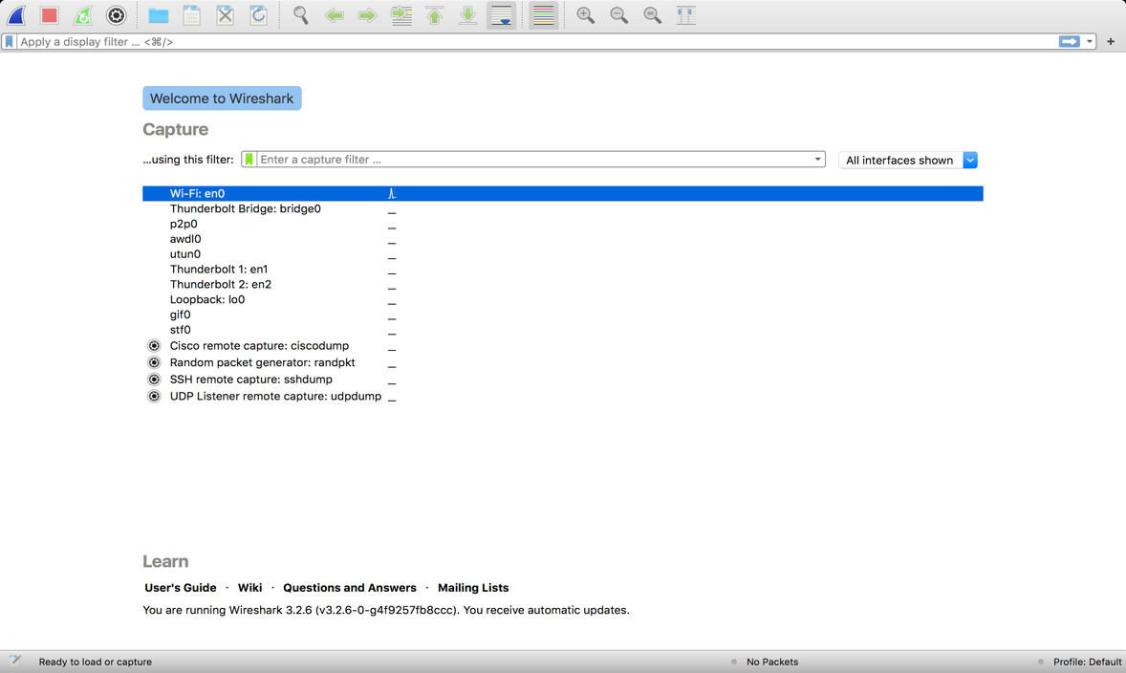

14. Using your computer, go to a Command prompt (in Windows type Command in the Search bar at the bottom left of your screen).

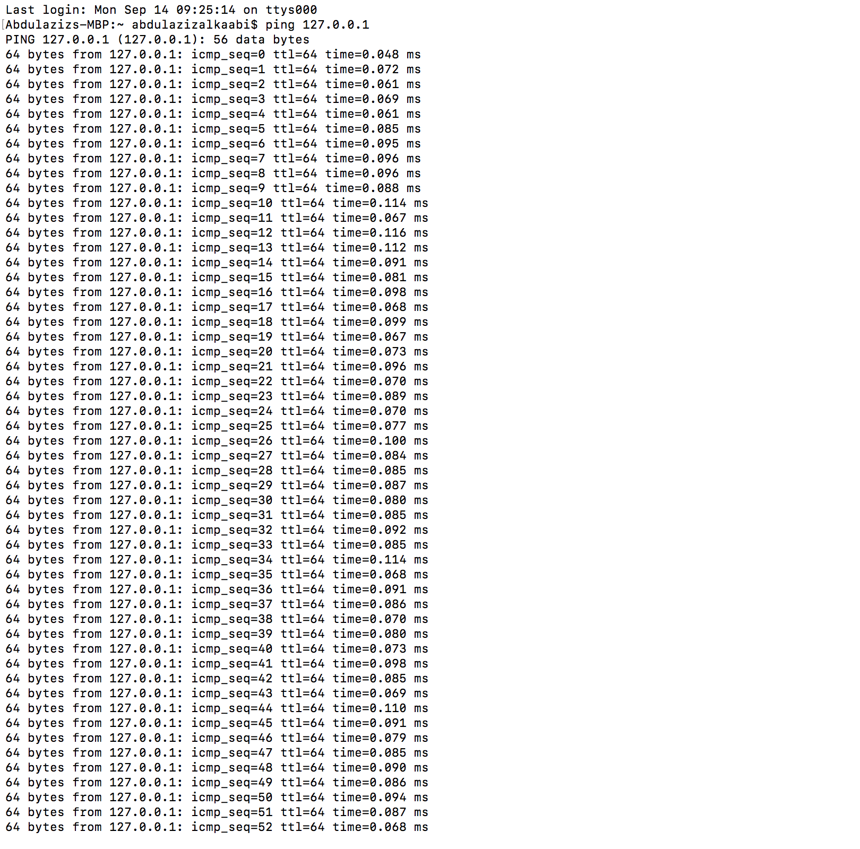a. Type Ping 127.0.0.1 and take a screen shot of the results.

b. Type Tracert www.amazon.com and take a screen shot of the results.

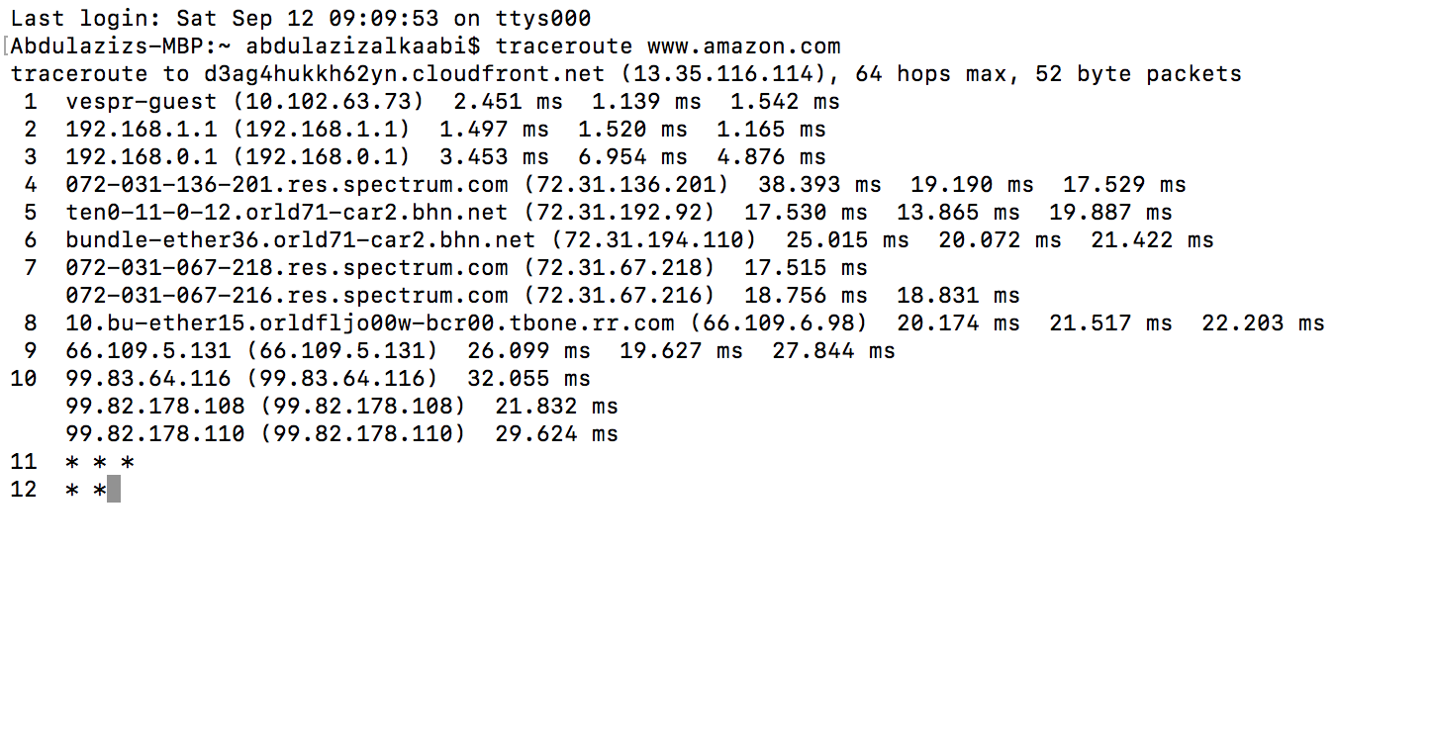c. Type Tracert www.ucf.edu and take a screen shot of the results.

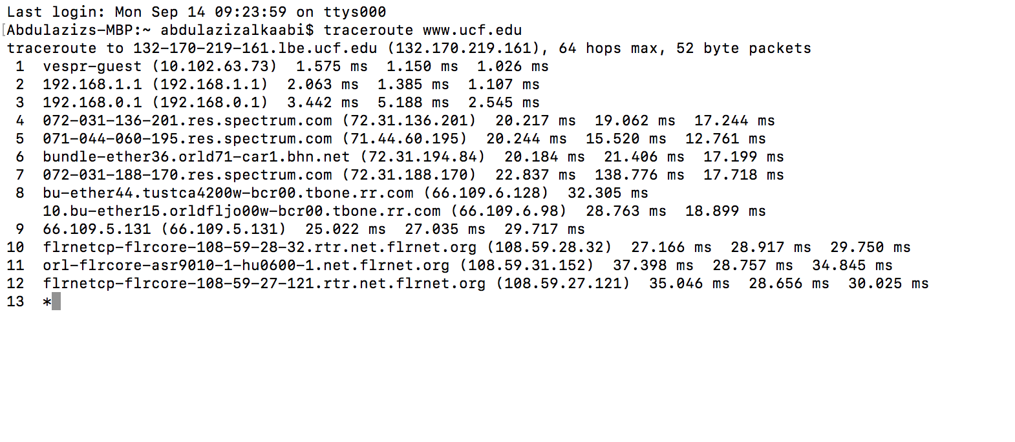15. Using your computer, go to a command prompt (same as #14).

a. Type route print –take a screen shot of the results.

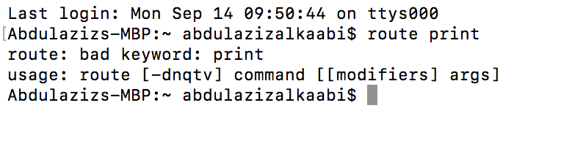

b. Type ipconfig /all - take a screen shot of the results.

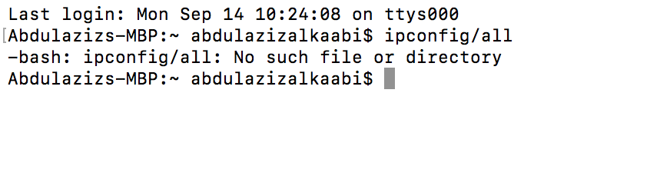

c. Type getmac - take a screen shot of the results.

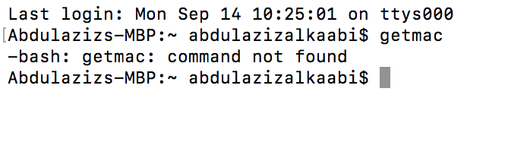

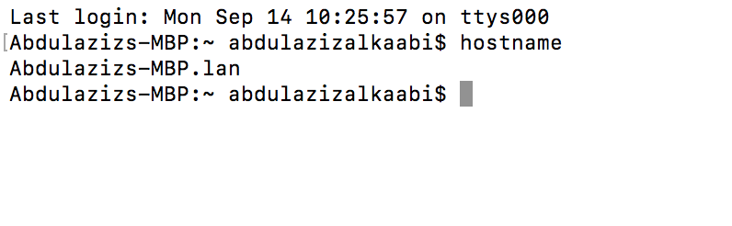d. Type hostname - take a screen shot of the results.